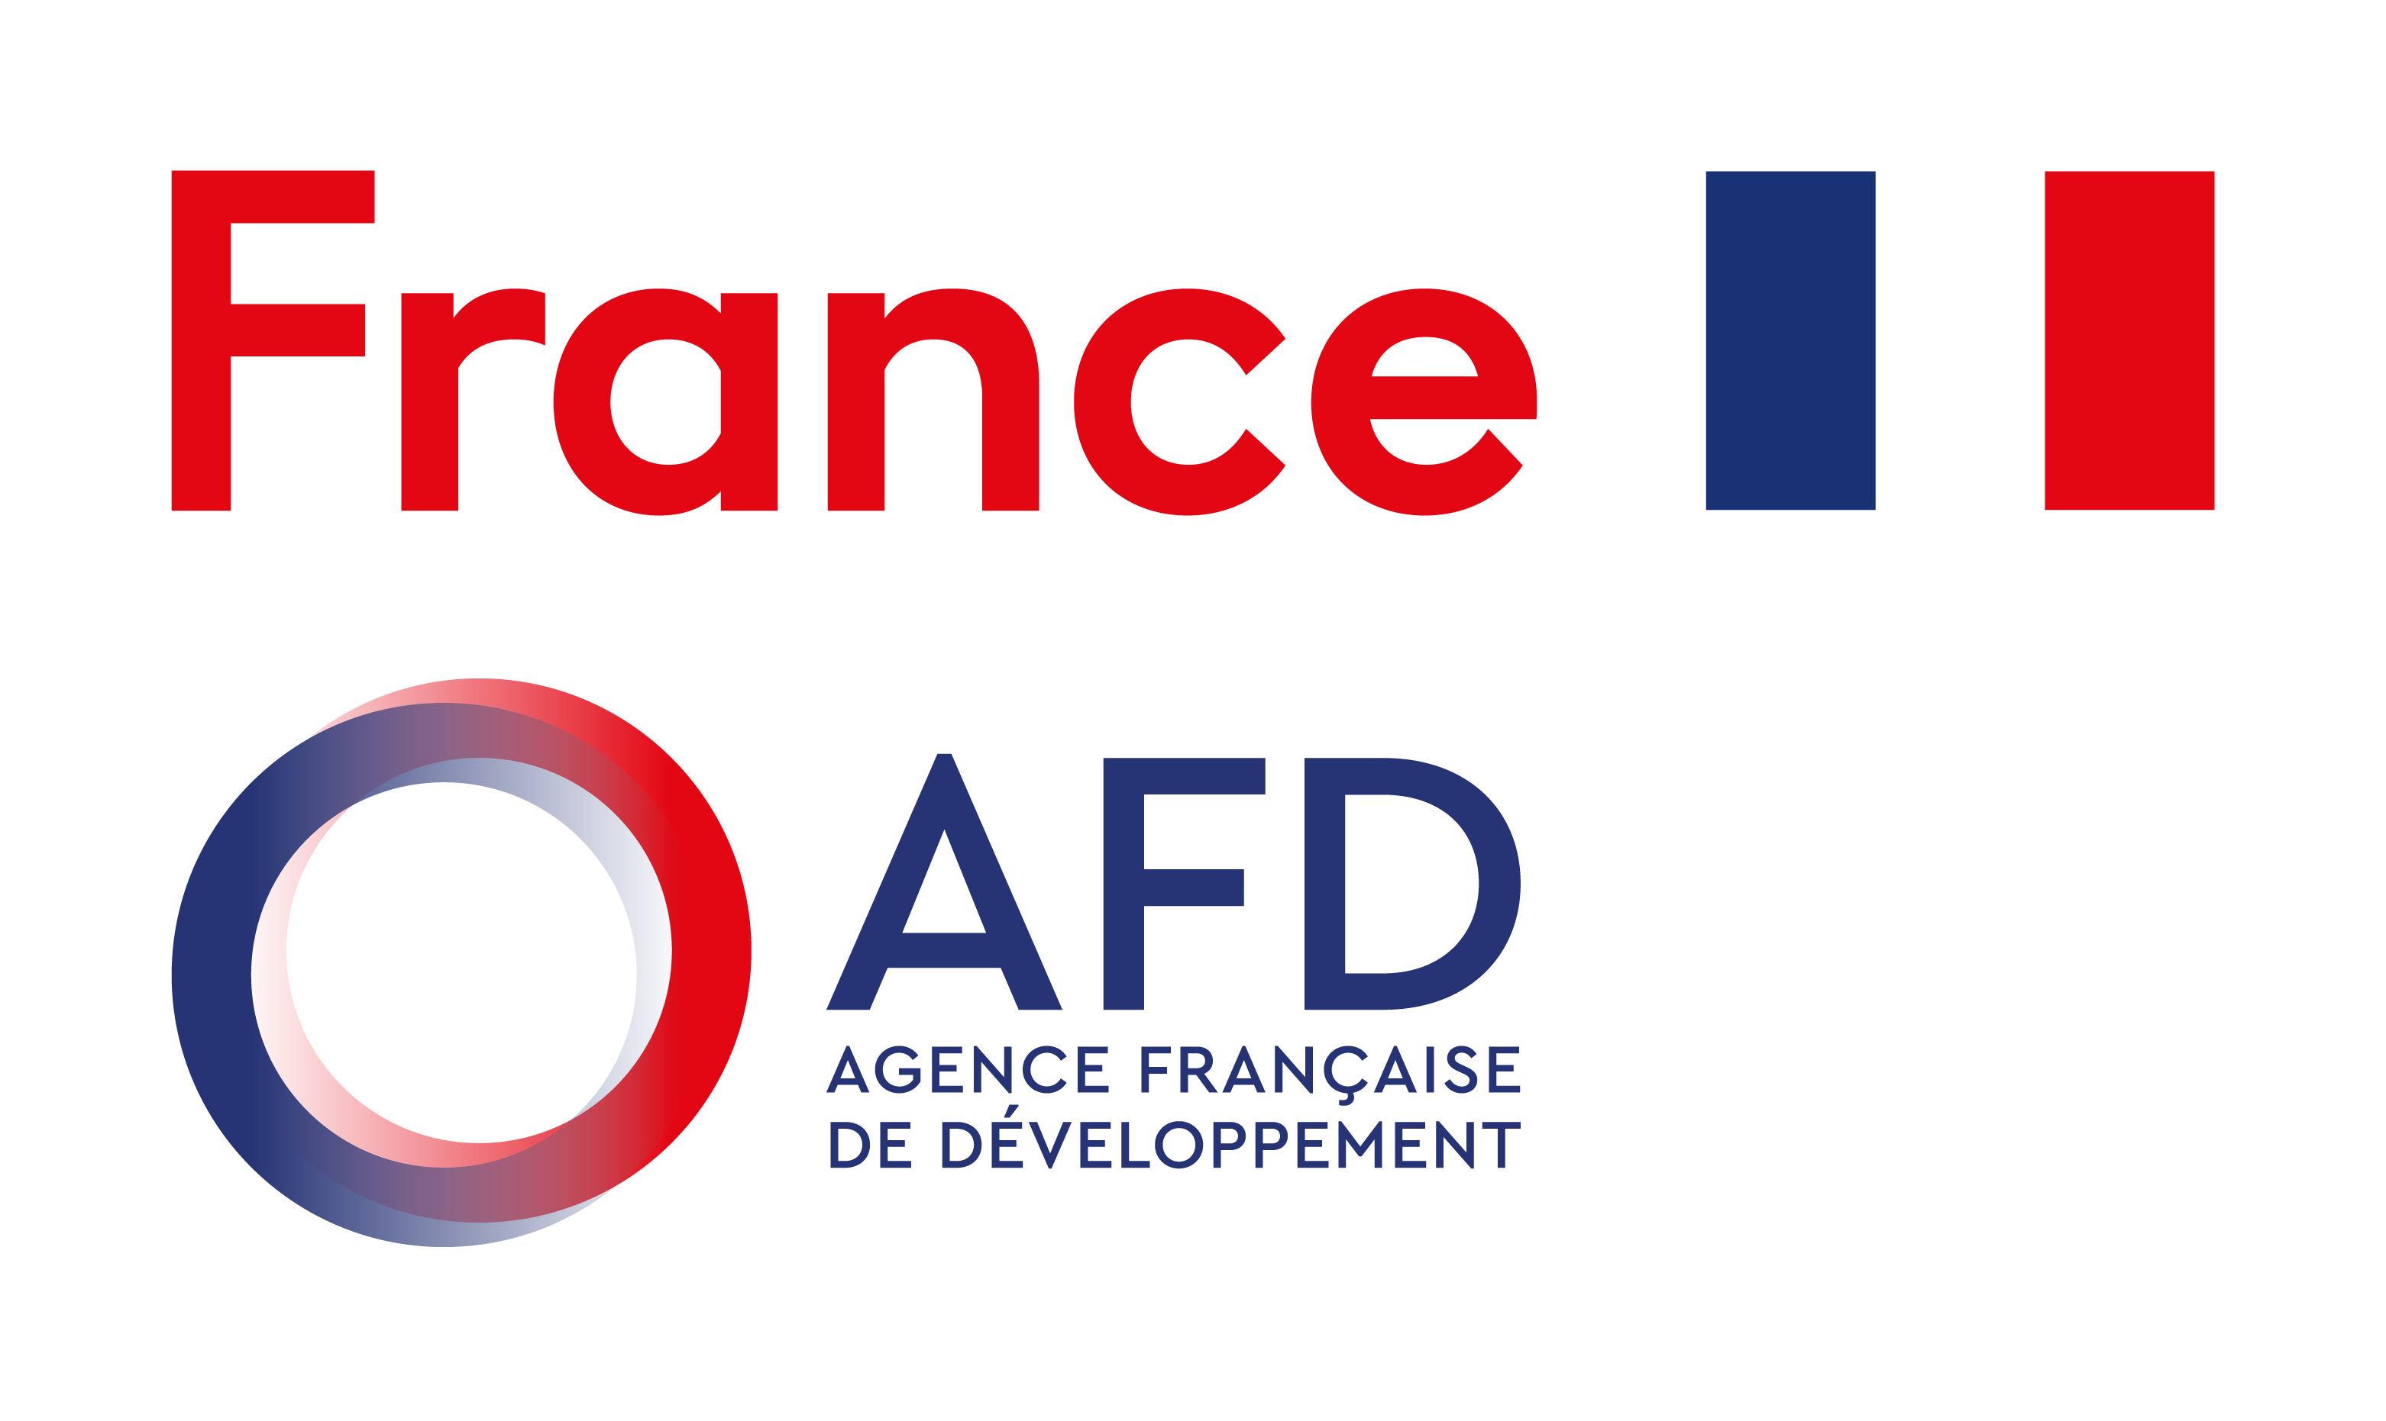
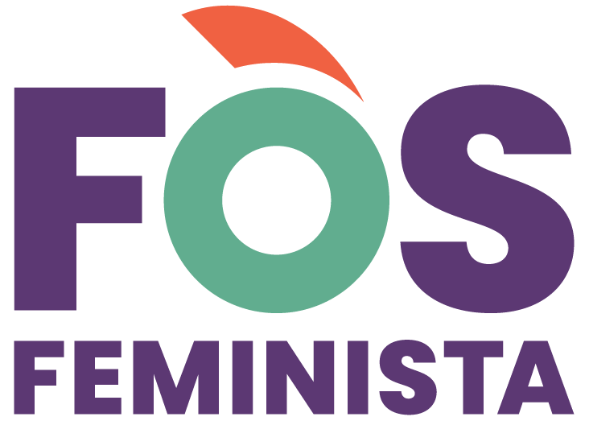
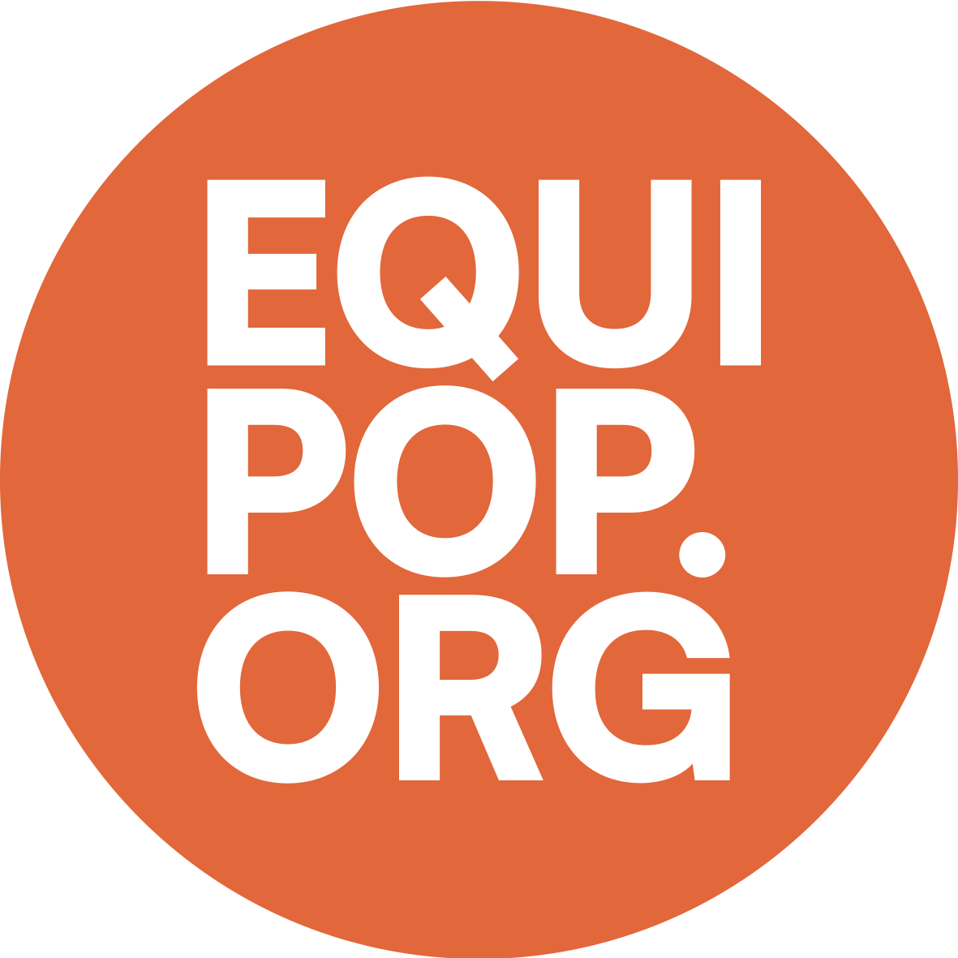
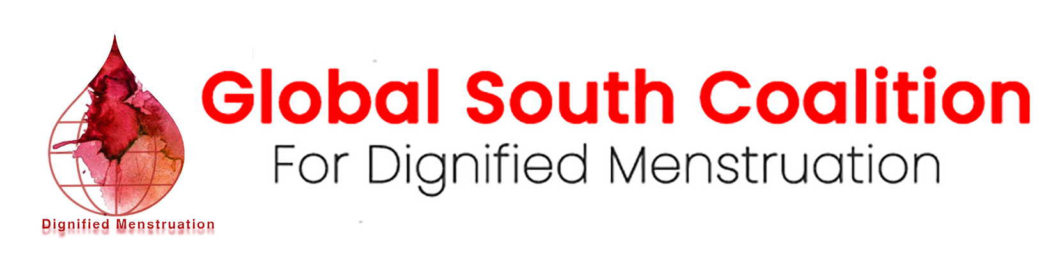
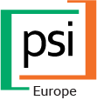

Advancing menstrual health research grants for Ethiopia
Knowledge Grants – call for applications

SANg Pour Sang Knowledge Grants

The Sang pour Sang consortium, led by Fòs Feminista, unites key organizations working on menstrual health: Equipop, PSI-Europe, and The Global South Coalition for Dignified Menstruation (GSCDM). This partnership advances menstrual health by centering Global South perspectives and addressing key challenges related to menstrual dignity.
The project covers nine countries: Benin, Guinea, Côte d'Ivoire, Nigeria, Cameroon, Pakistan, the Philippines, the Dominican Republic, and Haiti, with Ethiopia and Nepal as learning countries. Its goal is to transform structural drivers of menstrual discrimination, ensuring that women and girls can menstruate free from shame, taboos, fear, pain, social exclusion, discrimination, and violence.
The knowledge grants, as part of the Sang pour Sang program, are designed to support research and knowledge creation initiatives that generate actionable evidence and learning to advance menstrual health. A total of €150,000 is available under this call, from which we intend to award the following:
 | Category 1 | Category 2 | Category 3
Eligible Applicants | Civil Society Organizations | Individual Consultants; Academic Researchers | Young Researchers
Grant Size | €30,000 each | €20,000 each | € 10,000
Number of Grants | 3 | 2 | 2
Please note that the grants will only be distributed to organizations and individuals based in Ethiopia.
All grants will be awarded on a competitive basis, following a rigorous review process that considers the originality, relevance, methodological soundness, and potential for policy and advocacy impact of each proposal.
This grant program invites applications under several Research Focus Areas, each accompanied by a set of guiding sub-questions that reflect the key learning priorities for this call. Applicants should select one focus area that best aligns with their proposed work. Proposals are expected to address most of the sub-questions listed under that area, demonstrating how the planned research contributes to advancing learning within the chosen theme.
The Research Focus Areas are provided in the next section; applicants are requested to review them carefully before completing this application form. Applications that do not respond to the research focus areas listed will not be considered.

Submission Instructions
Please find the application template below. The template has five sections:
- Section A | Proposal Overview
- Section B | Narrative Proposal
- Section C | Research Timeline
- Section D | Relevant Experience
- Section E | Budget Proposal
Only applications with all five sections filled in will be considered.
Completed applications must be submitted by Friday, 24 November 2025, to Laura Karina Gutierrez at LKGutierrez@fosfeminista.org. Please also copy Tara Mukeku-Cilolo (TMukekucilolo@fosfeminista.org) and Swetha Sridhar (ssridhar@fosfeminista.org) in your email.
The review committee aims to finalize decisions by the end of November 2025, with funds disbursed in January 2026. Supported projects are expected to be implemented over a period of three to five months following disbursement.

Focus Areas for Research and Knowledge Creation
This grant program invites applications under several research focus areas. Each area includes a set of guiding sub-questions that reflect key learning priorities for this call. Applicants should select one focus area that best aligns with their proposed work. Proposals are expected to address the majority of the sub-questions listed under that area, showing how the planned research will contribute to advancing learning within that theme.

Research Focus 1: Mapping the Menstrual Product Manufacturing Ecosystem in Ethiopia
- Who are the main actors in the menstrual product manufacturing ecosystem?
- What size are these actors – are they small enterprises, medium- or large-scale enterprises? Under what type of legal and institutional structure are they operating (for-profit, social enterprise, not-for-profit etc.)?
- What is their production capacity and what is their turnover? To what extent does the quantum of local production fill market gap?
- What kinds of menstrual products are being produced domestically, and what factors influence producers’ choices in terms of product design, materials, and market positioning?
- What financing mechanisms and regulatory policies exist to sustain the production ecosystem, and what challenges persist within these areas?
- What distribution and supply chain structures exist to complement local production? What challenges persist in these areas, not just in sourcing material but also ensuring distribution to the last mile?
- To what extent, if at all, are local production companies and enterprises led by women or systematically excluded communities such as people with disabilities?
- To what extent do menstrual product enterprises take into consideration the “3Ps” in their operations - People (how are the needs and perceptions of women and girls addressed), Price (how is affordability ensured), and the Planet (what strategies are used to promote environmental sustainability)?
- What are emerging opportunities and continued challenges faced by local producers in Ethiopia?

Research Focus 2: Classification and Taxation on Menstrual Products
- What was the process through which menstrual pads were reclassified from a luxury item to a medical commodity in Ethiopia?
- What roles did various stakeholders (including but not limited to civil society organizations (CSOs), government actors, and the Menstrual Health (MH) platform) play in driving this reclassification? What specific strategies did each of these stakeholders use to advocate for, or implement, the policy change?
- To what extent does the taxation policy address different types of commodities, beyond just menstrual pads? What factors/evidence influenced this decision?
- What factors influenced the government’s decision to reduce rather than eliminate the tax on menstrual pads following reclassification?
- What considerations led the government to apply the tax exemption only to finished imported goods and not to the raw materials used in local production?
- What has been the impact of the tax reduction on the retail cost of menstrual commodities for end users?
- To what extent has the tax exemption translated into improved accessibility and affordability for consumers and buyers across different socioeconomic groups?
- How has the change in taxation affected local production of menstrual commodities, including but not limited to competitiveness, pricing, and sustainability of local manufacturers?
- What are emerging opportunities and continued challenges faced by both local producers and end users with regard to taxation on menstrual products?

Research Focus 3: Understanding the Menstrual Health (MH) Platform in Ethiopia
- What was the process and rationale behind the creation of the Menstrual Health (MH) Platform in Ethiopia?
- How has the MH Platform contributed to strengthening collaboration, solidarity, and shared resourcing among local producers of commodities in Ethiopia?
- What kinds of tensions or challenges has the MH Platform encountered in its coordination and collective decision-making processes, and how have these been managed?
- In what ways has the MH Platform functioned as an advocacy actor or pressure group in influencing government policy and action on menstrual health?
- How does the MH Platform collaborate with civil society organizations (CSOs) that work directly with women and girls, and what impact has this had on advancing menstrual health outcomes?

research Focus 4: Quality Control and Standardisation for Menstrual Products
- What role does the Ethiopian Standards Organization play in regulating and monitoring the quality of menstrual products available in the market?
- What are the key challenges in ensuring minimum quality and safety standards across Ethiopia’s diverse ecosystem of menstrual product producers?
- What strategies or capacity-building initiatives has the ESO implemented to help smaller or emerging producers meet required quality and safety standards while also helping them remain competitive in the market?
- To what extent have standardization and quality control measures improved product safety, reliability, and consumer trust among end users?
- To what extent does the standards framework also address issues of environmental sustainability and resilience?

Research Focus 5: Understanding Ethiopia’s Free Pads in School Policy
- How did the decision to provide free menstrual pads in schools in Ethiopia come about, and what factors informed this decision? What are the expected outcomes from this intervention?
- Who were the key actors (civil society organizations, international NGOs, private sector entities for example) that shaped, influenced or supported this policy decision, and what roles did each of them play?
- Which ministries were involved in the design and implementation of the school-based distribution program, and to what extent did it involve cross-ministerial collaboration?
- In what way, if at all, does this program complement distribution with menstrual health education and programs to address menstrual stigma and discrimination in school, which can act as roadblocks to accessing commodities, even if free?
- What is the current financing mechanism supporting the provision of free pads in schools, and what strategies are in place to ensure its long-term sustainability?
- What was the rationale for using schools as the primary site of intervention, considering the significant number of out-of-school (OOS) and dropout populations? Are there any strategies or plans to extend access to menstrual products to girls and women outside the formal school system?

Research Focus 6: women and girls’ Perceptions and Experiences of Menstrual Health Products
- What types and brands of menstrual products beyond reusable menstrual pads, are women and girls aware of, and what influences their choices regarding product type, brand, and usage?
- How do women and girls perceive the availability and affordability of menstrual health products in their communities?
- Where do women and girls typically source menstrual products, and what factors determine where and how they purchase or obtain them?
- How do women and girls perceive locally produced menstrual products compared to imported alternatives, particularly in terms of quality, safety, and reliability?
- Does the life stage and the circumstances of women or girls shape access to and choice of products?

Research Focus 7: Economic Decision-Making among Women and Girls
- How do women and girls make spending decisions about menstrual health products in relation to other household priorities and financial constraints?
- What is the perceived affordability of different types of products available in the market in Ethiopia?
- To what extent is cost a major barrier to purchasing in comparison to other issues? Are current prices perceived as affordable to women and girls who actually use the product
- Does price make a difference to the decision to pick locally produced commodities over imported menstrual products?

Research Focus 8: Menstrual Health and Dignity Needs of Vulnerable Groups
(For this research focus alone, applicants are not required to address all vulnerable or marginalized populations and/or all the questions listed below within their proposed research. Rather, proposals are encouraged to focus on one or two specific groups and/or one or two questions. Research should seek to generate a nuanced understanding of the menstrual health experiences, needs, and access barriers faced by the selected groups, and how these factors influence their overall well-being and participation in society.
For this research theme we welcome applications that look to create knowledge in creative formats as well – think videos or photo essays, short documentaries, and other formats outside the usual report!)
- What are the menstrual health and dignity experiences and needs of systematically excluded and vulnerable groups, such as adolescent girls, women and girls with disabilities, rural women and girls, incarcerated women, and those living in conflict or crisis-affected settings?
- What are the experiences of women living with fistulas in managing menstruation, and how do their needs differ from those of the broader population?
- Where do young people obtain information on menstrual health, what are their main sources of knowledge?
- What information do young people have about the various kinds of products that are available to manage their menstruation and where do they source these commodities from?
- To what extent have young people experienced menstrual health-related stigma or discrimination?

Section A | APPLICATION Overview

APPLICANT INFORMATION
Primary Contact Person  Please provide full name of the person who will be the contact for this application | Click or tap here to enter text.
Name of Organization  Please provide full registered name of the organization associated with this application, where relevant | Click or tap here to enter text.
Type of Applicant  Check the type that applies – please select only one | ☐ Women-led Organization  ☐ Youth-led Organization  ☐ Academic or Research Institution/ University  ☐ INGO/INGO Country Office  ☐ Independent Researcher  ☐ Independent Youth Researcher/Graduate Student  ☐ Private Sector Actor  ☐ Other, please specify:
Email | Click or tap here to enter text.

PROPOSAL OVERVIEW
Focus Area  Check the focus area that your research will address. Please select only one focus area from the list given alongside. More details on each of the focus areas are available in the supporting document circulated alongside the CfP | ☐ Mapping the Menstrual Product Manufacturing Ecosystem in Ethiopia  ☐ Classification and Taxation on Menstrual Products  ☐ Understanding the Menstrual Health (MH) Platform in Ethiopia  ☐ Quality Control and Standardisation for Menstrual Products  ☐ Understanding Ethiopia’s Free Pads in School Policy  ☐ Women and Girls’ Perceptions and Experiences of Menstrual Health Products  ☐ Economic Decision-Making among Women and Girls  ☐ Menstrual Health and Dignity Needs of Vulnerable Groups
Project Title | Click or tap here to enter text.
Research Questions  Please use this space to articulate your research questions demonstrating how they relate to the question listed under your theme of choice. We expect each application to address most of the questions under each theme, if not all | Click or tap here to enter text.
Brief Summary of Proposal  Please provide a 200-word summary of your proposed research. Mention the key activities and expected outcomes. This summary should give reviewers a quick understanding of your project and its relevance to the selected theme. | Click or tap here to enter text.
Proposed Approach and Methodology  Please briefly describe the approach or methodology you plan to use in this research. This could include qualitative or quantitative methods, participatory approaches, case studies, surveys, interviews, or other relevant methods. Explain why this approach is appropriate for your research questions and indicate the populations or communities you will work with | Click or tap here to enter text.
Geographic Focus  In 100 words, please explain the region/s of Ethiopia where your research will take place or focus on. Explain why this location is relevant for your research questions and how it aligns with your chosen theme | Click or tap here to enter text.
Inclusion and Participation of Marginalized Communities  Does your proposal elevate underrepresented voices, contexts, or communities. If yes, describe in 100 words which populations or groups your project will engage with and how your work seeks to amplify their perspectives and experiences | Click or tap here to enter text.
Dissemination Plan  Please describe how you plan to share the findings of your research, in 100 words. Include the intended audience/s and the formats or channels you will use | Click or tap here to enter text.

BUDGET OVERVIEW
Which grant are you applying for? | ☐ CSO Grant: € 30,000  ☐ Individual Grant: €20,000  ☐ Youth Grant: €10,000

OTHER
Did you or a member of your organization participate in the in-person learning workshop held in Addis Ababa on the 16th of October 2025? | ☐ Yes  ☐ No
How did you hear about this call for proposals? | ☐ Partner Organization  ☐ Social Media  ☐ Colleague  ☐ Other, please specify  Click or tap here to enter text.

Section B | Narrative Proposal
- Research Focus and Objectives
Please indicate the research focus area you have selected and specify which sub-question(s) under that theme your proposal will address. Explain why you chose this theme. (300 words)
Click or tap here to enter text.

- Research Questions
Describe the central research question(s) guiding your proposal. Explain how these questions contribute to advancing learning or generating new evidence on menstrual health. (300 words)
Click or tap here to enter text.

- Research Approach
Describe the overall approach and methods you plan to use. Describe the lens or perspective informing your approach (for example, a feminist, intersectional, sociological, economic, or public health framework – and how this is best suited to advance the conversation on menstrual health. (400 words)
Click or tap here to enter text.

- Research Methodology
Specify whether your research will involve primary data collection or secondary analysis. Please also clarify the form in which findings will be organized and presented (e.g., report, synthesis brief, case study series, etc. Finally, highlight the populations your research will engage and indicate how you will identify and reach participants or respondents. (400 words)
Click or tap here to enter text.

- Geographic Focus
Please specify the primary geographic area(s) your research will cover. Explain why this location is significant to your research questions or approach. (200 words)
Click or tap here to enter text.

- Inclusion of Marginalized Communities
Describe how your proposal will intentionally include or represent the voices of marginalized or underrepresented populations. Indicate which groups will be engaged, and how your approach ensures ethical and meaningful participation. (250 words)
Click or tap here to enter text.

- Contribution to the Menstrual Health (MHH) Ecosystem
Please explain how your proposed research adds value to the broader MHH ecosystem. Describe how your findings could inform, strengthen, or influence policy, programming, or practice, and how your work complements or builds on existing evidence or initiatives. If your proposal focuses on documenting a unique best practice or experience, please explain why this documentation is important and how it contributes to learning and action in the field. (350 words)
Click or tap here to enter text.

- Dissemination and Use of Findings
Outline your plan for sharing, communicating, and using the research findings. Explain how you will disseminate results to relevant stakeholders and how your dissemination efforts will complement the response to question 7. (300 words)
Click or tap here to enter text.

Section C | Research Timeline
(Please outline the key activities and milestones for your proposed research using the table below as a template, indicating the expected timeline for each. The total duration of the proposed project should fall within three to five months following December 2025. Feel free to add as many rows as you need or offer additional information by adding columns as well)
Main Milestone | Activities | Expected Output | Start | End
Milestone 1 | Activity 1.1 | Output 1
 | Activity 1.2
Milestone 2 | Activity 2.1 | Output 2
 | Activity 2.2

Click or tap here to enter text.

Section D | Relevant Experience
- Proven Track Record
Please describe any relevant experience your organization or team has in conducting similar research, documentation, or knowledge-generation work. If you do not have direct research experience, explain the strengths, capacities, or contextual experience that make you well placed to carry out this project and manage the proposed grant. (300 words)
Click or tap here to enter text.

- Networks, Coalitions, and Partnerships
Outline any networks, coalitions, or partnerships you are part of that can strengthen your proposed research. Describe how these relationships can support data collection, validation, dissemination, or policy and advocacy engagement. (250 words)
Click or tap here to enter text.

- Research Team Composition and Roles
Briefly describe the key members of your research team, their roles, and relevant expertise. (200 words)
Click or tap here to enter text.

Section E | Budget Proposal

Major Budget Heads
(Provide a brief breakdown of your proposed budget across major cost categories (for example, personnel, travel, materials, data collection, analysis, dissemination, etc.). You may use a simple table for this section. Please ensure that the total matches the amount stated in the budget overview in Section A. Budgets should be realistic and commensurate with the proposed scope and duration of your research)
Click or tap here to enter text.

